General Model Variables
Computational systems mechanobiology of Wound Healing - Tepole | Alkaline Phospatase and it’s role in the Immune System - Sloot | A multi-agent cell-based model for wound contraction - Boon | Computational Modeling of Inflammation and Wound Healing - Ziraldo | Biosimulation of Acute Phonotrauma: an Extended Model
 | Inflammation Triggering Moeties (ITMs) | Cells - |  | TGFB  bFGF  TNFa  IL1B  IL-6,8,10  MMP-8  Hyaluronan
  Fibroblasts
  Myofibroblasts
  Leukocytes
 | Alkaline Phosphatase (AP) – Endogenous in liver, supplemented,
 | Neutrophils – Resting, Activated, Apoptotic, Necrotic |  | Neutrophils
 | Pro-inflammatory Cytokines | Cytokines -  tPA  PDGF  TGFB | Cytokines -  TNFa  IL-1B  IL-10  TGF-B1
 | Anti-inflammatory Cytokines
 | Macrophages – Activated, Resting |  | Macrophages
 |  | Fibres -  Collagen  Fibrin | Fibroblasts | Collagen  Elastin

Combining AP model and ABMs

- Level of exposure to immune system determined by blood flow to area (e.g. angiogenesis / distance to vessels)

Inflammation Triggering Moeties (ITMs)

Alkaline Phosphatase (AP) – Endogenous in liver, supplemented,
Neutrophils – Resting, Activated, Apoptotic, Necrotic
- In wound – produce antimicrobial substances and phagocyte bacteria
- First cells to migrate to site of inflammation, they are later replaced by macrophages
Pro-inflammatory Cytokines
- IL-1β
- TNFα
Anti-inflammatory Cytokines
TGF-β (multifunctional cytokine)
- Released by macrophages
- Attracts macrophages and fibroblasts
- Stimulates resting monocytes – upregulates inflammatory response
- While also downregulating cytokine production in monocytes and macrophages
- inhibits activated macrophages
- Excessive action may be responsible for tissue damage from scarring

Macrophages – Activated, Resting
- Establish long-lasting chemical sources of cytokines and keratinocytes
- Maintain production of TBF-B

Proangiogenic Factors
- Vascular endothelial growth factor (VEGF)
- Fibroblast growth factors

Keratinocytes
- Chemically attracted by TGF-a
- Can contribute to de novo hair follicle formation
- Build the new epidermis: in healthy skin, proliferative keratinocytes are polarised by adhering to the basement membrane (can continually renew the epidermis)

Fibroblasts
- Assemble the new ECM in the dermis
- Migrate in response to initial inflammatory signals, especially towards PDGF and TGF-B
- Increased collagen deposition in the presence of TGF-B
- Respond to strain by altering heir collagen deoposition rate and producing TGF-B
- Remodeling: break down the scar and reorganise the ECM

Biomarkers
TGF-b
Liver enzymes (AST, ALT) | Excessive levels indicate hepatocytic injury
Interleukins IL-(1B,6,8,10) | 6 – Found to be the cytokine whose levels predict patient outcome. Correlates with infection/sepsis. Correlates with severity of burn injury.  10-used in AP model.
TNF-a | Initiating factor in the activation of the host response and subsequent cytokine release during trauma. Correlates with the severity of burn injury. Pro-angiogenic factor.
Matrix metalloproteinase (MMP)-8 | Involved in remodeling process, probably not that useful for now.
Procalcitonin(PCT) & C-reactive protein(CRP) | Sepsis. PCT is the most reliable measure of sepsis. CRP is often used as a general proxy to characterise inflammatory status.
Leptin | Stimulated by pro-inflammatory cytokines (eg IL and TNFa). Cytokine-like hormone that links nutritional status with the immune system, while enhances innate(+adaptive) immunity. Related to regulation of stress. Pro-angiogenic factor.
WCC
Neutrophils
Temperature
TBSA

We know that macrophages produce tgfb which attracts fibroblasts which deposit collagen, therefore its better to limit the interaction with the other system through some approximation here

When a patient has come in, they are likely to have gone through the first stage of response – hemo. So its nota problem the wound model does not cover this

We also know burns melt the cells blocking the wound from immediate infection (I know this is inaccurately worded)

the ap model by itself is already a good indicator of schemic or immune shock that leads to organ damage but maybe it is also worth investigating the effect on wound repair or only doing it in right situations? Damage to other organs will slow further recovery of wound, shortage of

We also know that certain cells are required for angiogenesis, the level of co-evolution between a wound cell and the innate immune response is governed by its access to the blood supply, also granted by angiogenesis

The AP model will act like an engine for the blood composition of the abm wound model, which could be extended to 3d or approximate this

For the presentation, optional slides explaining what system dynamic and abm models mean

Level of stress biomarkers

Age, weight, height, gender, skin type sociomarkers. This are for greater accuracy and personalisation for patient trajectories laterally

Specific Parameter Tables with values

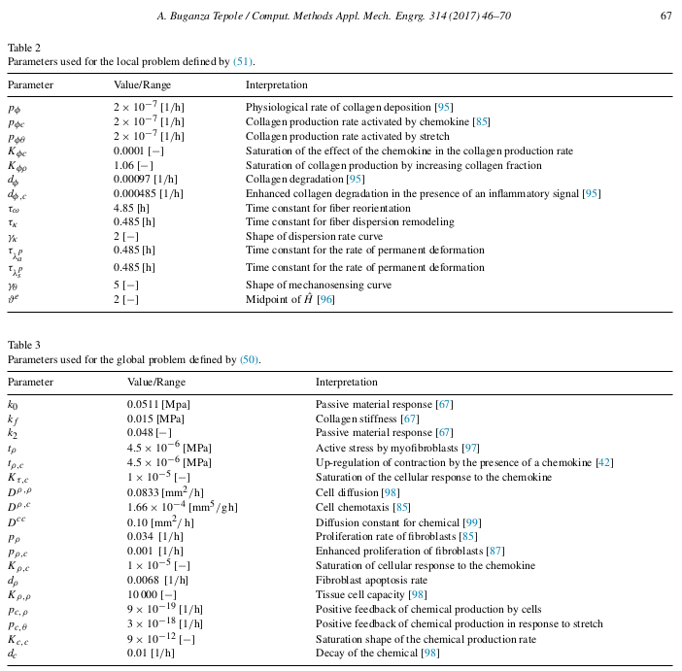
Positive Observations

- The AP model will allow us to adapt wound healing models so they are coupled to the innate immune system.

Negative Observations

- Scarring is caused by the excessive action of cytokines such as TGFb and TNFa, but these proteins are fundamental to the healing process. Extending the healing process to minimise scarring may increase the likelihood of complications and healthcare costs. Perhaps, anti-TGFb can be used later in healing process?
- As far as organ damage is concerned the original AP model is sufficient and would not

2 main goals:
- What is necessary to adjust the ABM wound healing model to simulate burn wounds? How can we adjust it? Whats the difference with normal and burn wound healing?
- Scale of injury, wound healing models have not been designed to be valid for large wounds. Actually the previous models tended to model wounds as circular
- Burns coagulate the surface cells of the burn so that infection is less likely in first few days
- Burns destroy the hair follicles which contain sources of stem cells
- Different zones not used in wound healing
- Deep (third degree) burns are so serious largely because they destroy the many hair follicles and sweat glands that invaginate deep into the dermis and serve as efficient sources of epithelial regrowth after more superficial injury.

- What is the role of the innate immune system in burn wounds and what is the link with the ABM model? Ruud (burn wound specialist probably knows this and Peter will setup a meeting with him, probably some specific molecule generated by immune system controlling this process)

Plan
- Start with basic inflammation / immune 2D ABM connected to the AP model, with simple pro/anti inflam agents. Extend to include specific cytokines. Extend to proliferation/angiogensis.
- Mesa python framework

Questions

Presentation Story
There are several validated models which simulate one or two of the phases of wound healing. Almost all of these models use the same cell populations as the AP model, e.g. pro/anti inflammatory cytokines, activated/resting macrophages etc. However, these models only consider the immune system indirectly, while usually explicitly referring to the specific cytokines that activated macrophages release such as TGF-β, TNF-α and interleukins.
Several of the papers, have validated collagen deposit rates in the presence of inflammatory signals and chemokines, but rely on accurate tissue and blood composition. Essentially, if we can connect the immune system to the specific cytokines involved in almost all aspects of the healing process (TGFB,FGF,PDGF, VEGF, TNFa, IL), much of the legwork has actually been done by these papers.
If we can integrate the AP model with inflammation models that refer to specific cytokines and validate this, extending the model for the proliferation, contraction, and re-epitheliasation should not pose too much of an issue. Angiogenesis may prove more of a challenge, however, may be crucial to capture the exposure to the blood supply (and therefore HIIS).

TGF-beta

It is part of almost all processes of wound healing except angiogenesis, and will perhaps be the lynchpin of our model, getting its dynamics, interactions and levels validated and realistic in relation to the HIIS, is crucial.

Maybe talk about some other key chemicals here …

We can add photos of the particular phase to the slides going through the different phases of healing with their respective model.
Discussing these models, what they measure, how they relate to the AP model, their results and validation should form the meat of the presentation.

Specifically, as far as I can tell, every phase of healing is connected to the immune system but no other papers have modelled this relationship. If we have a validated model connecting AP to any phase of wound healing, is essentially novel research but the inflammation phase is intuitively the best place to start. We should seriously think about how we would be able to validate this though, although the original paper is directly concerned with inflammation (although a different type than that found in wound healing)

Excessive scarring may be caused by the presence of too much:

- Contraction
- TGF-b → Fibroblasts → Collagen

